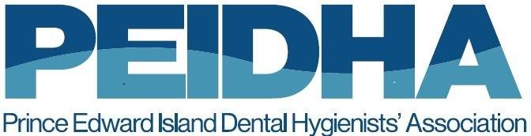
Council Nominee Application Form
PEI Dental Hygienists’ Association (PEIDHA)

The Nominations Committee of the PEI Dental Hygienists’ Council is required to present a slate of Nominees to the Annual General Meeting of the PEIDHA. To help the Committee match talents, skills, experiences, and interests with the needs of the Council, we would appreciate knowing a little more about you.
Please complete the following:

- Name:
2.Mailing Address (used for occasional mail-out of materials):
Street # and name/PO Box _______________________________________________
City : __________________________________
Postal Code:______________________
Province: ___________________________
3.Home Address if different from #2 above:
Street # and name/PO Box _______________________________________________
City: __________________________________
Postal Code: ______________________
Province: ___________________________

4.Contact Phone Numbers:
Cell phone:
Home phone:
Work phone:
5.Practice Setting:
- Pediatrics
- Public Health
- General
- Speciality – please explain: _________________________________
- Independent Practice
- Education

6.Practice Years Experience
- 0-5 years
- 6-10 years
- 11 + years

7.Past and current involvement in other Councils/Boards:
Organization | Role/Title | Dates of Service

8.Skills/Competencies
We do not expect all Council members to have all skills/competencies.

Check “Experienced” if you have experience with the Skill/Competency noted.
Check “Willing to Learn” if you are not comfortable with the skills/competencies but would be willing to learn.

Skills/Competencies | Experienced | Willing to Learn
Dealing with emails on a regular basis
Virtual meetings
Working with electronic documents
Use of social media (not required but considered an asset)
Staying connected with team members; reporting progress to others
Planning, running, and/or evaluating events
Working with and understanding financial statements
Leading and/or training colleague

Please forward completed application to:
By Email: peidentalhygienists@hotmail.com
By ground mail: PEIDHA, 81 Prince Street Charlottetown, PE C1A 4R3

If you have any questions, please email us at: peidentalhygienists@hotmail.com

